**NC State University**

**Department of Electrical and Computer Engineering**

**ECE 463/563: Fall 2021 (Rotenberg)**

**Project #3: Dynamic Instruction Scheduling**

**by**

**<< AYUSHYA CHAUHAN >>**

NCSU Honor Pledge: "I have neither given nor received unauthorized aid on this project."

# Student’s electronic signature: AYUSHYA CHAUHAN____________________________

(sign by typing your name)

Course number: _________563________

(463 or 563 ?)

1. Large ROB, effect of IQ_SIZE

* 1. Trace_gcc

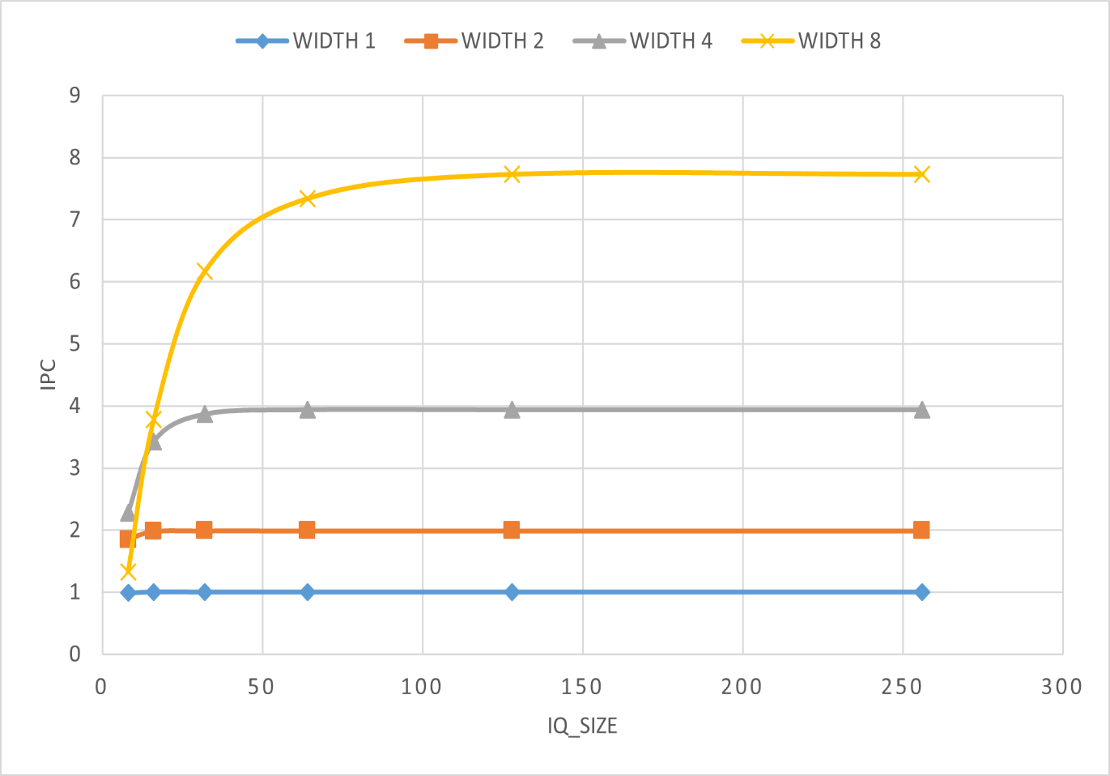

Graph 1: trace_gcc IQ_SIZE Vs IPC

|  |  |  |  |  |
| --- | --- | --- | --- | --- |
| IQ_SIZE | W=1 | W=2 | W=4 | W=8 |
| 8 | 0.99 | 1.85 | 2.28 | 1.33 |
| 16 | 1 | 1.98 | 3.43 | 3.78 |
| 32 | 1 | 1.99 | 3.87 | 6.17 |
| 64 | 1 | 1.99 | 3.94 | 7.34 |
| 128 | 1 | 1.99 | 3.94 | 7.73 |
| 256 | 1 | 1.99 | 3.94 | 7.73 |

Table 1: Trace_gcc1

* 1. Trace_perl

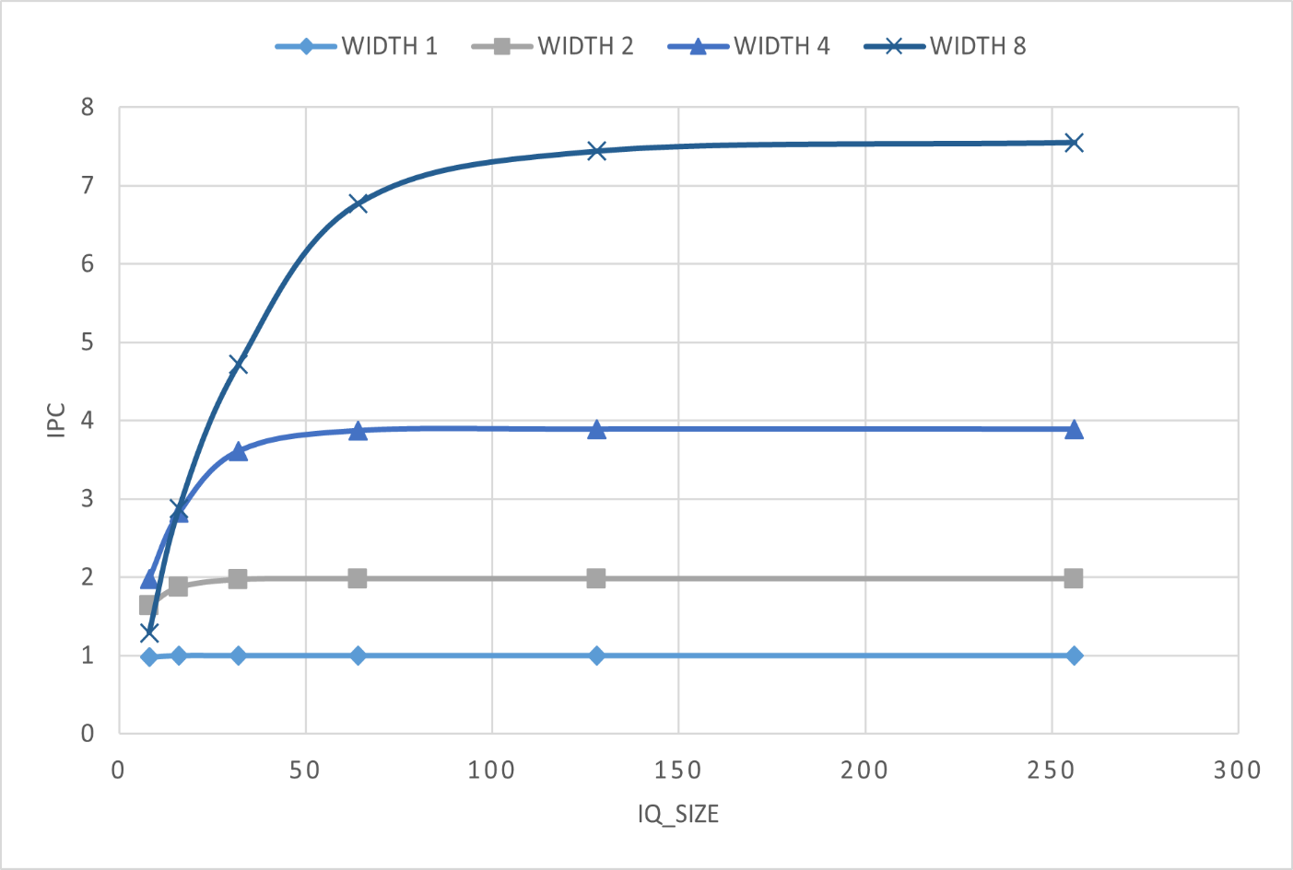

Graph 2: trace_perl IQ_SIZE Vs IPC

|  |  |  |  |  |
| --- | --- | --- | --- | --- |
| IQ_SIZE | W=1 | W=2 | W=4 | W=8 |
| 8 | 0.98 | 1.64 | 1.98 | 1.29 |
| 16 | 1 | 1.87 | 2.82 | 2.88 |
| 32 | 1 | 1.97 | 3.61 | 4.72 |
| 64 | 1 | 1.98 | 3.87 | 6.77 |
| 128 | 1 | 1.98 | 3.89 | 7.44 |
| 256 | 1 | 1.98 | 3.89 | 7.55 |

Table 2: Trace_perl1 values

1.3 Graph Analysis

|  |  |  |  |
| --- | --- | --- | --- |
|  | **“Optimized IQ_SIZE per WIDTH”**  Minimum IQ_SIZE that still achieves within 5% of the IPC of the largest IQ_SIZE | |  |
|  | Benchmark 1 | Benchmark 2 | |
| W=1 | 8 | 8 | |
| W=2 | 16 | 32 | |
| W=4 | 32 | 64 | |
| W=8 | 128 | 128 | |

Discussion

In the first experiment, keeping the size of ROB constant, by increasing the size of Instruction Queue while changing Width, Instruction per cycle proportionally increases a well.

The best IPC value is achieved at Width=8 and IQ size= 128. Similar results can be achieved with just 5% less value range with a IQ size lower than it.

The ideal value of IPC is the width size. The IPC keeps on increasing till a saturation point is reached. The saturated value is less than Width but very close to ideal value.

Increasing the Width brings the superscalarity and provides parallelism.

The difference between ideal value and achieved value keeps on increasing as we increase width. For e.g.:

For gcc trace file, we can see for w=1 the ideal value is 1 and achieved value is 1 , similarly for w=2, achieved value is 1.99, w=4, achieved value=3.94 and for w=8 the achieved value is 7.73.

For perl trace file, we can see for w=1 the ideal value is 1 and achieved value is 1 , similarly for w=2, achieved value is 1.98, w=4, achieved value=3.89 and for w=8 the achieved value is 7.55.

**1.4 EFFECTS OF ROB_SIZE**

Graph 3: trace_gcc effect of ROB_size

TRACE_GCC

|  |  |  |  |  |
| --- | --- | --- | --- | --- |
|  | 1 | 2 | 4 | 8 |
| 32 | 0.99 | 1.88 | 2.38 | 2.33 |
| 64 | 0.99 | 1.95 | 3.43 | 3.96 |
| 128 | 0.99 | 1.98 | 3.87 | 6.18 |
| 256 | 0.99 | 1.98 | 3.87 | 7.63 |
| 512 | 0.99 | 1.98 | 3.87 | 7.73 |

Graph 4: Trace_perl, effect of ROB_size

TRACE_PERL

|  |  |  |  |  |
| --- | --- | --- | --- | --- |
|  | 1 | 2 | 4 | 8 |
| 32 | 0.98 | 1.79 | 2.19 | 2.18 |
| 64 | 0.98 | 1.97 | 3.16 | 3.51 |
| 128 | 0.98 | 1.97 | 3.83 | 5.36 |
| 256 | 0.98 | 1.97 | 3.87 | 7.05 |
| 512 | 0.98 | 1.97 | 3.87 | 7.44 |